**Tool: Apache Spark** 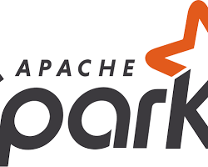

Official Website: https://spark.apache.org/

Purpose:

* Apache Spark is an open-source unified analytics engine for large-scale data processing. Spark is used for batch processing, stream processing, and machine learning tasks on large datasets